Assignment 3

Creating two tables Department and Employee

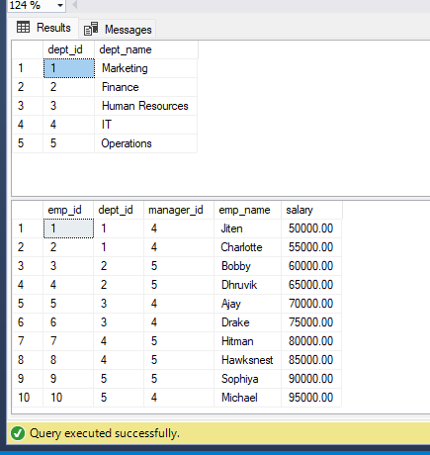

Query 1: Write a SQL query to find Employees who have the biggest salary in their Department

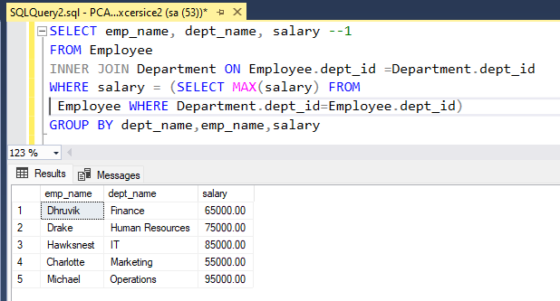

Query 2 : Write a SQL query to find Departments that have less than 3 people in it.
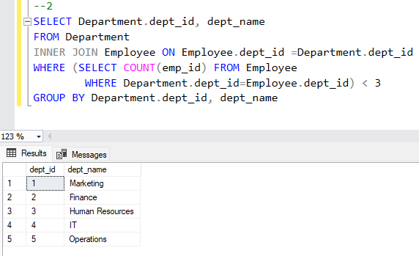
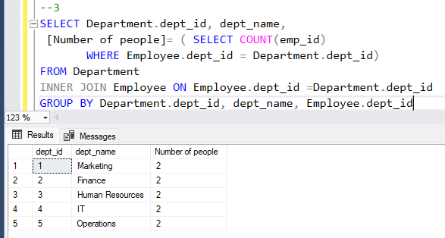
Query 3: Write a SQL query to find All Department along with the number of people there

Query 4: Write a SQL query to find All Department along with the total salary there

